702, Room

Thank you for your use.
The room detail information and the delivery of the key of the room.

[Street address]
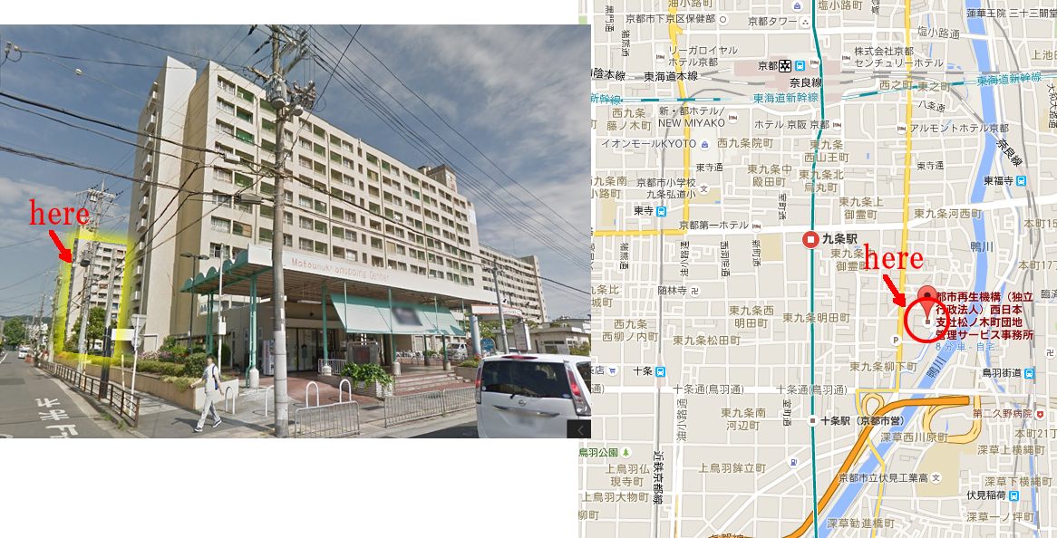
Kyoto, Kyoto Prefecture, Minami-ku, Minamimatsunoki-cho, 1-1 Matsunoki housing complex 3-702

MAP
https://goo.gl/maps/158NyYV4c172

案内写真はこちら
GoogleDrive
https://drive.google.com/folderview?id=0B5HTn1vzBas1YWlKNlVDQ1NjX28&usp=sharing
百度伝
http://pan.baidu.com/s/1jHP3Qjc

702号室
ご利用ありがとうございます。
お部屋の詳細と鍵の受け渡しについてご連絡いたします。
住所
京都市南区東九条南松ノ木町1番地の1
松ノ木町団地3号棟７０２号室

[nearest stations]
1.a 8min by walk from KUJO station, Station number 'K12' (Next to Kyoto station by subway) 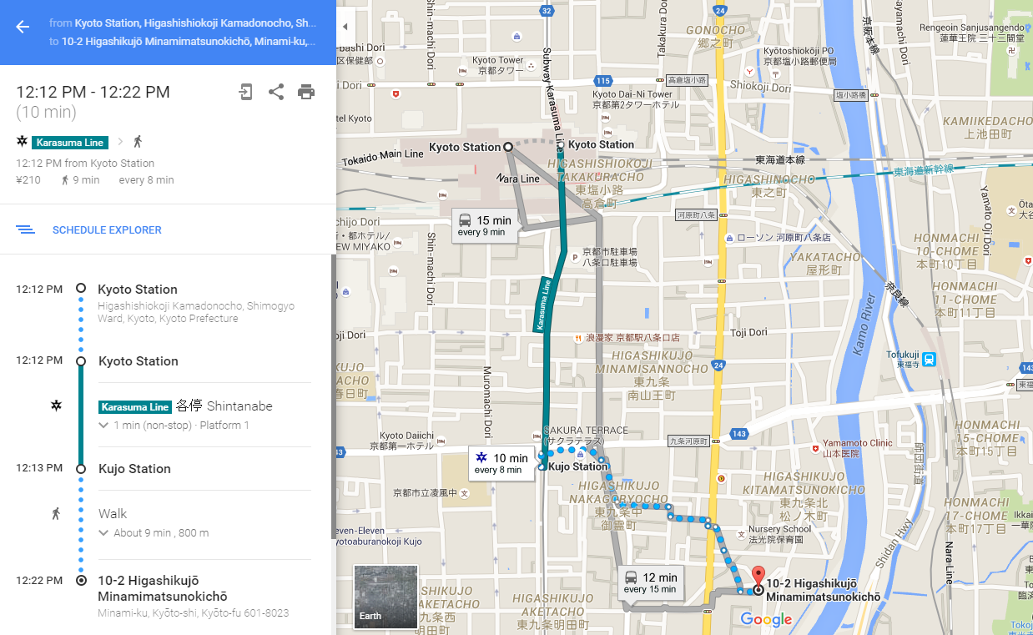

2.a 10 min from the "Toba Road" station by Keihan train

It is also accessible on foot from Kyoto Station.

最寄駅
京阪本線「鳥羽街道」駅から徒歩約10分
京都市営烏丸線「九条」駅から徒歩約8分
京都駅から徒歩でもアクセス可能です。

[Delivery method of the key]

1.At first

Please take the room key. There is On the set post of first floor center of Building No,3
Caution! There is set post each building. The room building is Three
The back of the building, what through passed the courtyard.
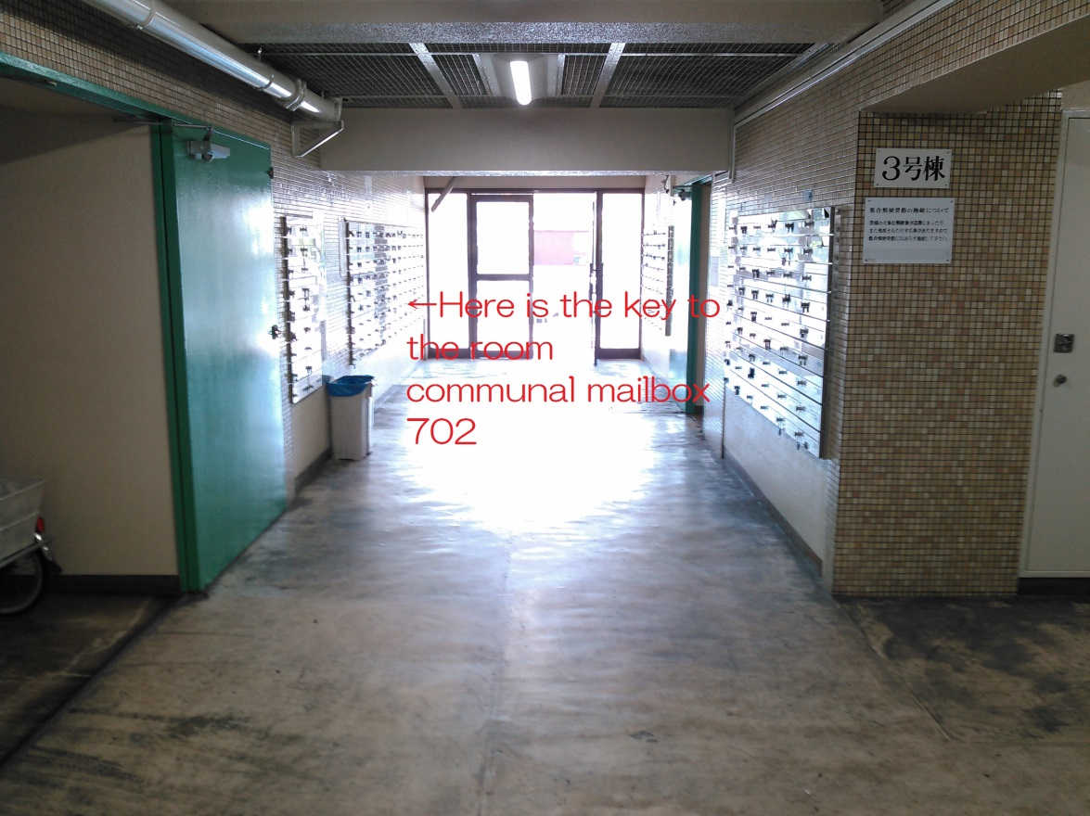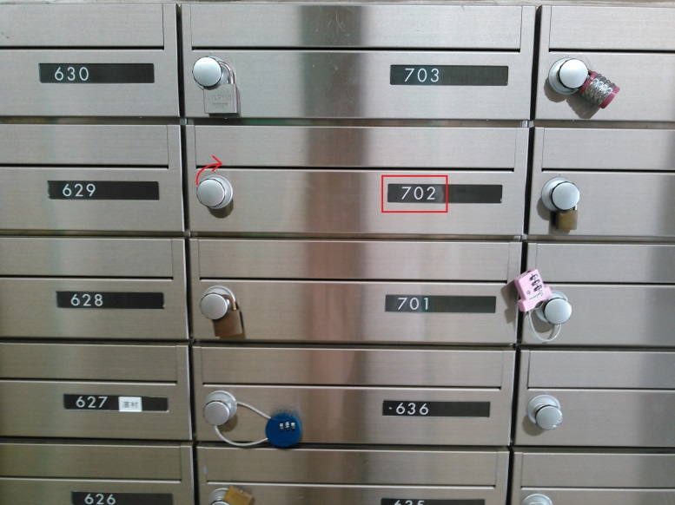
2.Go to the room to room702 of building No,3.
[CHECK OUT]

Please keep in return the key to set the post when you return is closing the key of the room.

鍵の受け渡し方法
3号棟の1階中央に集合ポストがございます。
お帰りの際は部屋の鍵を閉めて集合ポストに鍵を戻しておいてください。

住所
京都府京都市南区南松ノ木町1-1松ノ木団地3-702
MAP
https://goo.gl/maps/158NyYV4c172

